EXP NO: 2
Create a Simple Cloud Software Application for Flight Reservation System Using Any Cloud Service Provider to Demonstrate SaaS
Aim
To develop a simple cloud-based Flight Reservation System using Zoho Creator, demonstrating the Software as a Service (SaaS) cloud model for managing passenger booking information and automatically calculating the total ticket amount.

Procedure
- Log in to Zoho Creator.
- Create a new application named Flight Reservation System.
- Create a form and add the following fields:
  - Passenger Name
  - Flight Number
  - Source
  - Destination
  - Ticket Price
  - Number of Tickets
  - Total Amount
- Configure Total Amount as the output field.
- Add a Deluge script to calculate:
Total Amount = Ticket Price × Number of Tickets
- Save the application.
- Run the application in the cloud.
- Enter the passenger and flight details.
- The application automatically calculates and displays the total ticket amount.
- Verify the output and save the record.

Implementation
if(input.Ticket_Price != null && input.Number_of_Tickets != null)
{
input.Total_Amount = input.Ticket_Price * input.Number_of_Tickets;
}

info "--------------------------------";
info "FLIGHT RESERVATION SYSTEM";
info "--------------------------------";
info "Passenger Name : " + input.Passenger_Name;
info "Flight Number : " + input.Flight_Number;
info "Source : " + input.Source;
info "Destination : " + input.Destination;
info "Ticket Price : Rs. " + input.Ticket_Price;
info "No. of Tickets : " + input.Number_of_Tickets;
info "Total Amount : Rs. " + input.Total_Amount;
info "Booking Status : Success";

Output
Sample Screenshots:
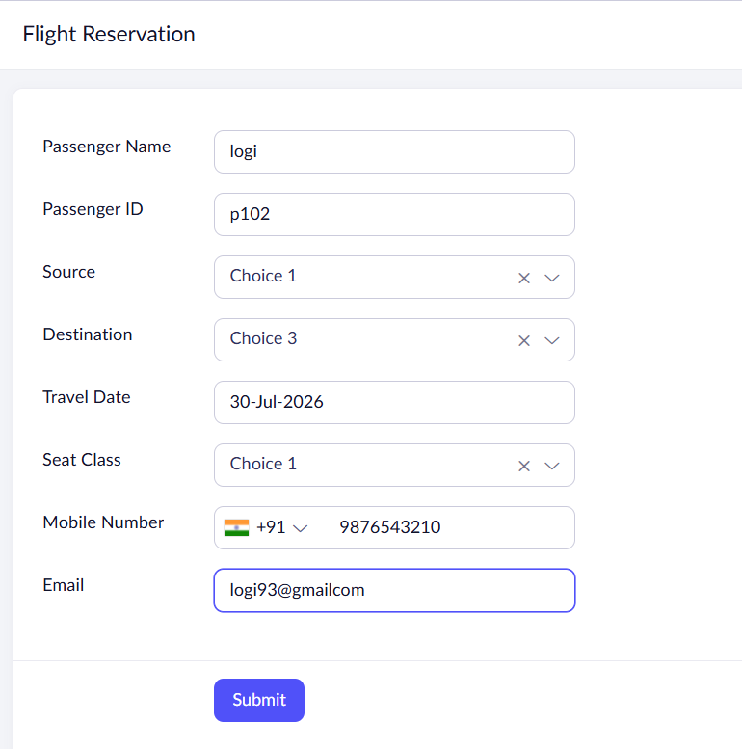

Result
The cloud-based Flight Reservation System was successfully created using Zoho Creator (SaaS). The application accepts passenger and flight booking details and automatically calculates the total ticket amount, demonstrating the Software as a Service (SaaS) cloud computing model.

